

Working Together to Improve Women’s Health 2009:
Focus on Bleeding Disorders

One Day Multidisciplinary Forum Covering Gynaecological & Obstetric Aspects of Bleeding Disorders in Women

Designed for Consultants, Trainees and Nursing staff from Haematology, Gynaecology and General Practice

Organised jointly by The Centre for Haemostasis & Thrombosis and Department of Women’s Health

Friday 13th November 2009

Royal Society of Medicine
1 Wimpole Street
London W1G 0AE

Course Organisers:

Dr Bella Madan & Ms Debra Holloway
Multidisciplinary Women’s Clinic
The Centre for Haemostasis and Thrombosis

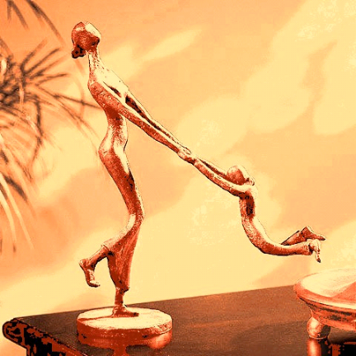

Course fee: £80.00 (Payment by cheque only)
Course includes: Programme – 9.15 am – 5.00 pm
Trade show
Lunch and refreshments for course duration
CPD points available for participants

For registration details and further course information contact: Ms Marcia Milne - marcia.milne@gstt.nhs.uk
Tel: - 020 7188 2789 - Fax: - 020 7401 3125

Full course information and registration details are available at our website: www.c4ht.com

Course Programme

Working Together to Improve Women’s Health 2009:

Focus on Bleeding Disorders

A Multidisciplinary Forum

Friday 13th November 2009, Royal Society of Medicine, London

Meeting to be Inaugurated by Ms Patricia Moberly

TIME | TITLE | SPEAKER
9.15 – 10.00 | REGISTRATION AND COFFEE
MORNING SESSION 10.00 – 13.05
10.00 – 10.15 | Background: Setting up of Women’s Multidisciplinary Clinics | Dr Bella Madan
10.15 – 10.45 | Cutting Edge Approach to Menorrhagia | Ms Diana Hamilton-Fairley
10.45 – 11.15 | von Willebrand's Disease: The Burden in Women | Professor Christine Lee
11.15 – 11.45 | Case Based Discussion – A Tale of Two Specialities | Ms Debra Holloway
11.45 – 12.05 | COFFEE BREAK
12.05 – 12.35 | Pitfalls in the Interpretation of Coagulation laboratory results in Pregnant and Non-Pregnant states | Dr Bella Madan
12.35 – 13.05 | Inheritance of Haemophilia: Role of Clinical Genetics | Ms Alison Lashwood
13.05 –14.00 | LUNCH & TRADE SHOW
AFTERNOON SESSION 14.00 – 17.00
14.00 – 14.30 | The Patients’ Perspective | Patients
14.30 – 15.00 | Practical Management of Women with Inherited Bleeding Disorders during Pregnancy and Labour | Dr Pippa Kyle
15.00 – 15.30 | Obstetric Analgesia and Anaesthesia for Women with Bleeding Disorders | Dr Geraldine O’Sullivan
15.30 – 15.45 | COFFEE BREAK
15.45 – 16.15 | Management of the Neonate with a Suspected Inherited Bleeding Disorder | Dr Jay Alamelu
16.15 – 16.45 | Blood Products: Current Trends in the Management of Women with Bleeding Disorders | Dr David Bevan
16.45 – 17.00 | Questions and Answers

Speakers (In order of presentations)

Working Together to Improve Women’s Health 2009:

Focus on Bleeding Disorders

Friday 13th November 2009

Dr Bella Madan Consultant Haematologist
Centre for Haemostasis and Thrombosis
St Thomas’ Hospital

Ms Debra Holloway Consultant Nurse in Gynaecology
Department of Women’s Health
Guy’s Hospital

Ms Diana Hamilton-Fairley Consultant Gynaecologist & Obstetrician
Department of Women’s Health
St Thomas’ Hospital

Professor Christine Lee Emeritus Professor of Haemophilia &
Honorary Consultant Haematologist
Oxford Haemophilia Centre & Thrombosis Unit

Ms Alison Lashwood Nurse Consultant in Clinical Genetics & PGD
Genetics Department
Guy’s Hospital

Dr David Bevan Director and Consultant Haematologist
Centre for Haemostasis and Thrombosis
St Thomas’ Hospital
Dr Pippa Kyle Consultant Obstetrician
Women’s Services
St Thomas’ Hospital

Dr Geraldine O’Sullivan Consultant Anaesthetist
Department of Anaesthetics
St Thomas’ Hospital
Dr Jay Alamelu Consultant Paediatric Haematologist
Centre for Haemostasis and Thrombosis
St Thomas’ Hospital

A special thank you to the patients who have kindly taken the time and effort to
attend and speak today.

Contact details

Dr Bella Madan & Ms Debra Holloway
Multidisciplinary Women’s Clinic
Centre for Haemostasis and Thrombosis
Guy’s and St Thomas’ NHS Foundation Trust
1st Floor, North Wing
St Thomas’ Hospital
Westminster Bridge Road
London SE1 7EH
Phone +44 (0) 20 7188 2781
Fax +44 (0) 20 7401 3125

Dr Bella Madan & Dr Lucy Chappell
Antenatal Clinic
St Thomas’ Hospital
8th Floor, North Wing
Westminster Bridge Road
London SE1 7EH
Phone +44 (0) 20 7188 2802
Fax +44 (0) 20 7401 3125

Transport links
Location

One Wimpole Street provides high quality conferencing and event space in central London. The fantastic location of One Wimpole Street puts you right in the heart of London's vibrant West End and within easy access of most of the capital's major transport links.
For further information please visit www.rsm.ac.uk
Royal Society of Medicine
1 Wimpole Street
London
W1G 0AE

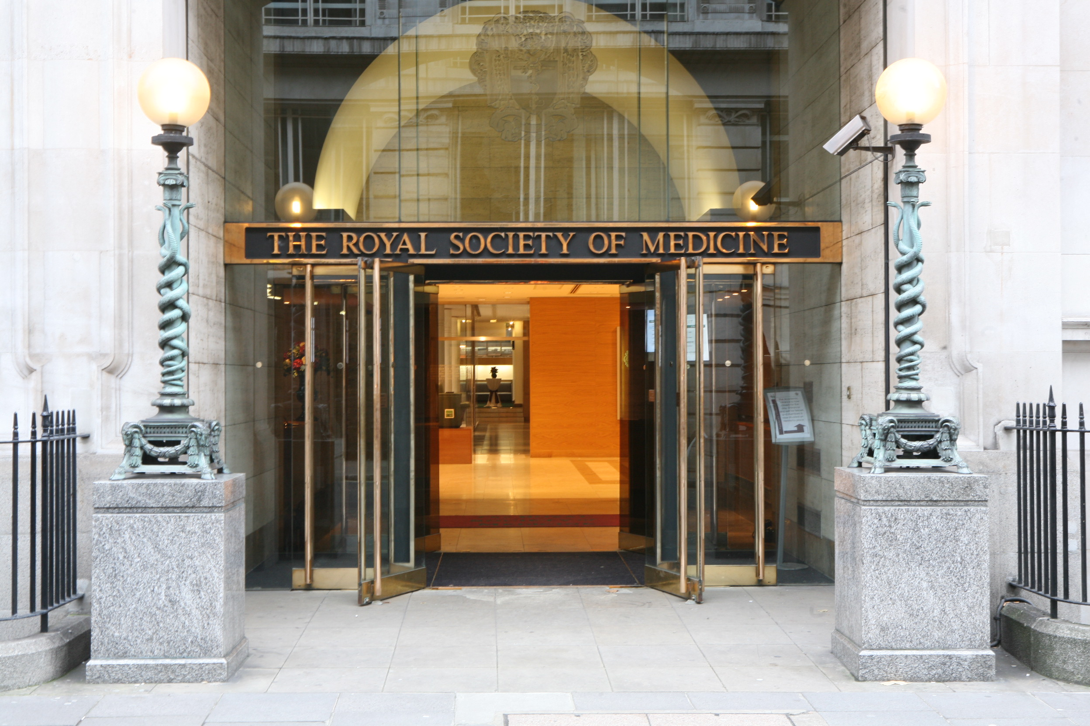

By bus
Nearest bus routes: 6, 7, 10, 13, 15, 23, 25, 30, 55, 73, 94, 98, 113, 137, 139, 159, 175, 189, 274, 390 are all within walking distance to the RSM.

By car
The RSM is in the congestion charging zone. Wimpole Street is a one-way street, approached from Henrietta Place.
Parking near the RSM
Car parks are located in Cavendish Square and Marylebone Lane, both five minutes walk away.
For more information visit the City of Westminster website.

By foot
1 Wimpole Street is located behind John Lewis and House of Fraser, off Oxford Street.

How to find us

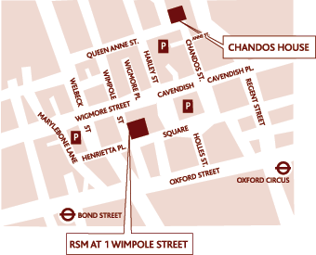

View a scalable map on the Multimap website.

By London Underground
Nearest Tube stations: Central and Jubilee lines to Bond Street (Less than 10 minutes walk) or Victoria, Bakerloo and Central lines Oxford Circus (Less than 10 minutes walk).

Nearest Train Stations: London Bridge and Charing Cross are the nearest railway stations. For further information, please call National Rail Enquiries on 08457 484 950 or visit National Rail website www.nationalrail.co.uk

Travelling in London
For further information about travelling in London go to the Transport for London website: www.tfl.gov.uk.

Accommodation

There are many accommodation options in the London area. All London hotels have good links to public transport and to the Royal Society of Medicine site. For further information on accommodation options visit your preferred hotel booking service.

The Centre for Haemostasis and Thrombosis

Working Together to Improve Women’s Health 2009:
Focus on Bleeding Disorders

Friday 13th November 2009
9.15am – 5.00pm

Royal Society of Medicine, 1 Wimpole Street, London W1G 0AE

Registration Form
PLEASE WRITE IN CAPITALS

Title __________ First name ______________________ Surname ________________________________

Job Title ______________________________________________________________________________
Institution/Affiliation______________________________________________________________________

Mailing address _________________________________________________________________________

______________________________________________________________________________________

Postal code City Country______________________

Telephone Country code Area code Number_____________

Mobile ________________________________________________________________________________

Fax Country code Area code Number_____________

Email_________________________________________________________________________________

Dietary requirements

Do you have any special dietary requirements? (E.g. vegetarian, religious requirements, etc)
If yes, please give details _______________________________________________________________

How did you find out about this course?

Word of mouth  E-mail shot  Journal advert  Website 

(Please state which) ___________________________________________________________________

Registration Fee

Course participant’s registration
Course fee £80.00

Participant’s registration fee includes:
• Admission to all sessions
• Access to Trade Show
• Attendance Certificate
• Lunch and refreshments for the course duration

Condition of payment

No confirmation will be sent until completed form and payment has been received.

PLEASE RETURN THE COMPLETED FORM TO:

Ms Marcia Milne
Women’s Bleeding Disorders Course
Centre for Haemostasis and Thrombosis
The Haemophilia Reference Centre
1st Floor, North Wing
St Thomas’ Hospital
Westminster Bridge Road
London SE1 7EH

OR

PLEASE POST CHEQUES TO THE ABOVE ADDRESS
AND FAX THE COMPLETED FORM TO:

++44 (0) 20 7401 3125

CHEQUES SHOULD BE MADE PAYABLE TO:
“GUY’S AND ST THOMAS’ NHS FOUNDATION TRUST”

Panel Questions

The Centre for Haemostasis and Thrombosis

Working Together to Improve Women’s Health 2009:
Focus on Bleeding Disorders

Friday 13th November 2009
9.15am – 5.00pm

Royal Society of Medicine, 1 Wimpole Street, London W1G 0AE

To encourage further delegate involvement and increase the information communicated through the course, the course organisers have dedicated a section of this year’s Bleeding Disorders course programme to an expert panel question and answer session. This session will be used to answer questions received from the delegates through the registration process.

Delegates are asked to provide any questions which you would like the panel to answer. If you have any question which you would like to see answered by the assembled expert panel, please complete this form and return with your registration documents. The panel will attempt to answer as many questions within the time allocated.

Delegate Name: _________________________________________________________

Designation: ____________________________________________________________

Question: _______________________________________________________________
________________________________________________________________________ ________________________________________________________________________
________________________________________________________________________
________________________________________________________________________
________________________________________________________________________
________________________________________________________________________
________________________________________________________________________

Please return this form with registration documents

